Mini Project

Dataset:-Pima indians diabetes.

- Open rapidminer select file=>new process=>blank=>start, following screen is appear.

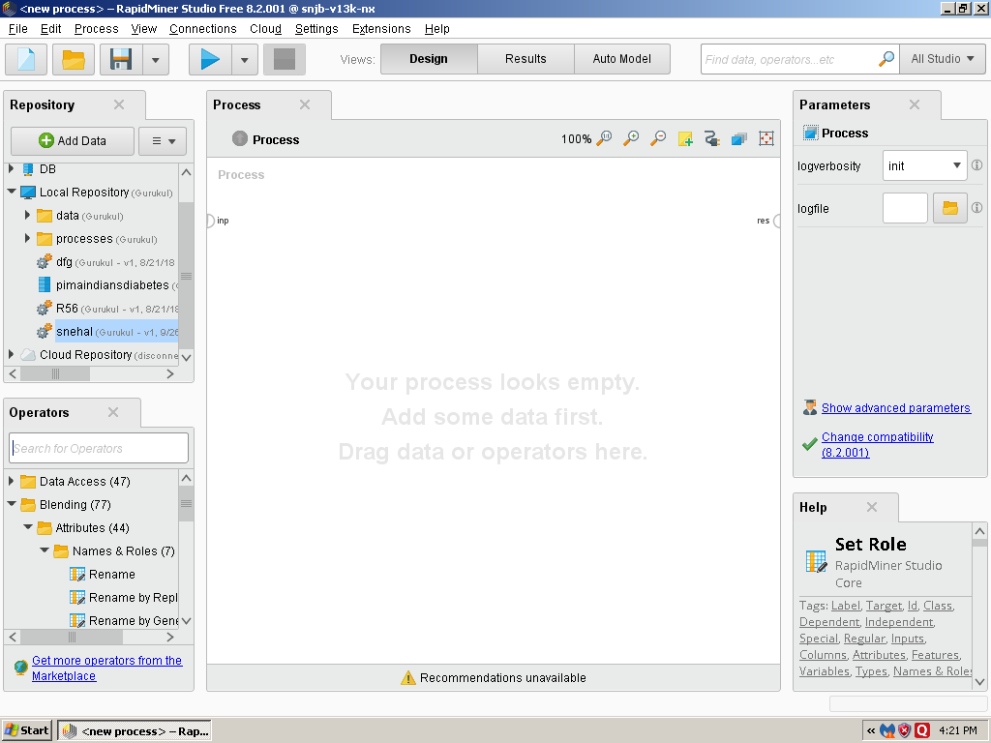

2) Add dataset on Retrieve operation then perform the different operations with using different operators.

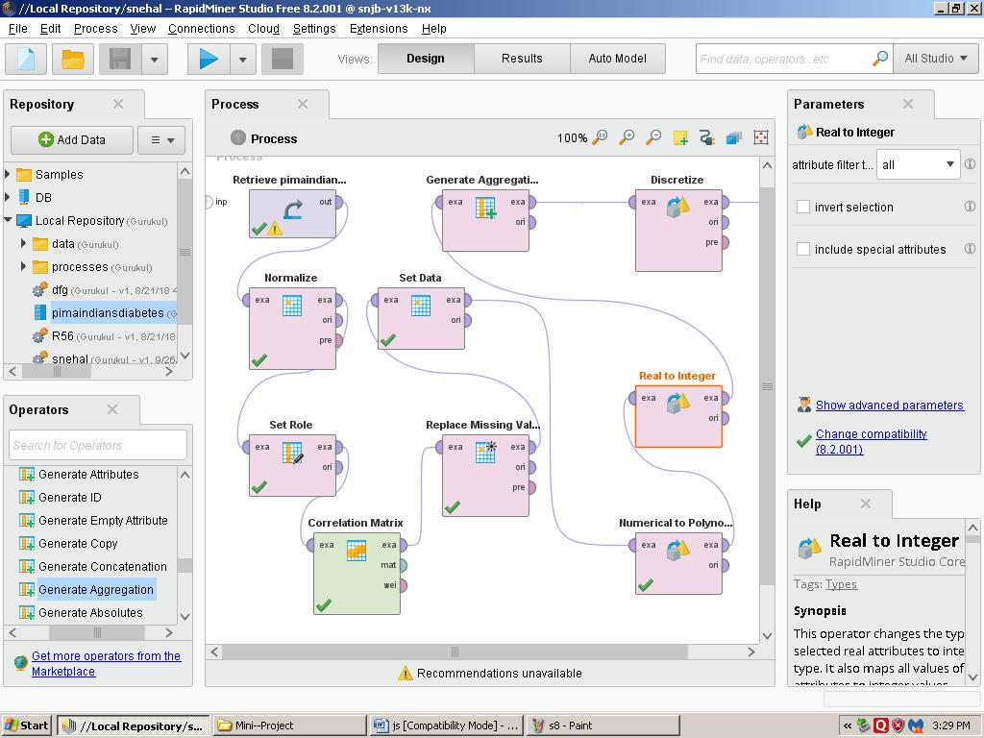

- Press F11 i.e. run process locally then result will be display.

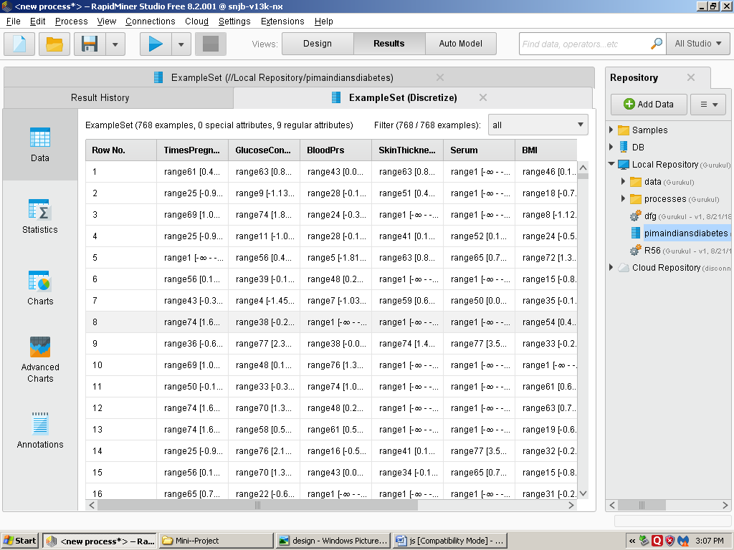
1)

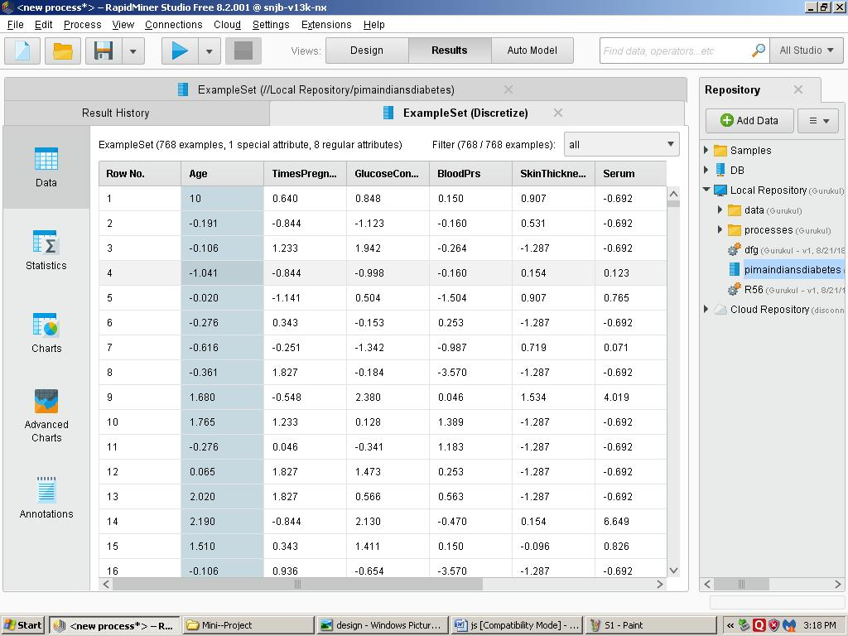
2)

- If you want to view dataset statistically then press statistics.

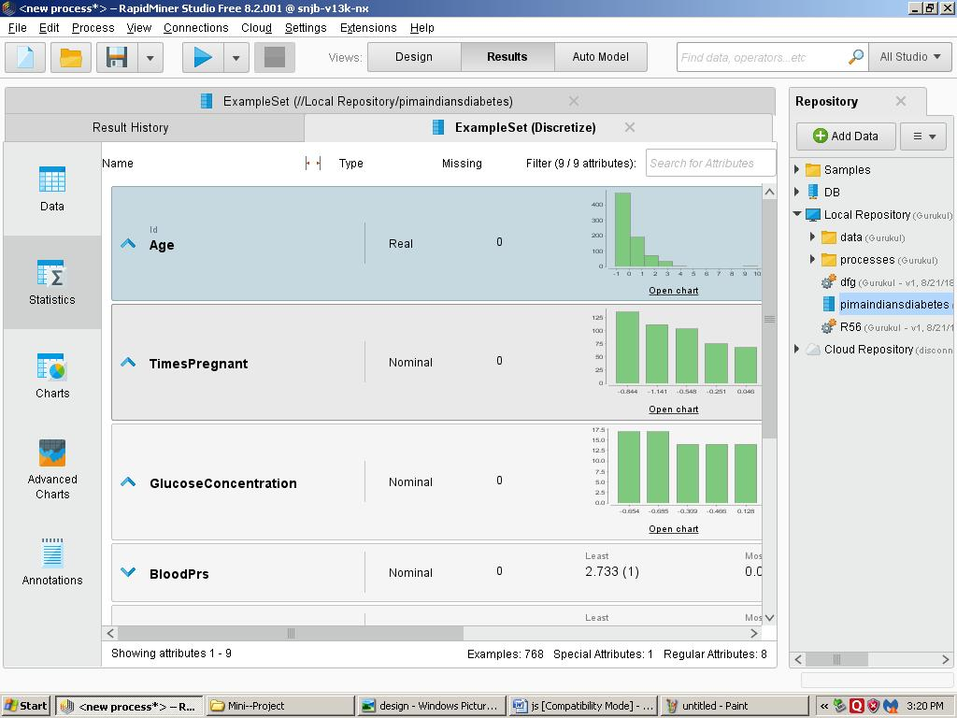
1)

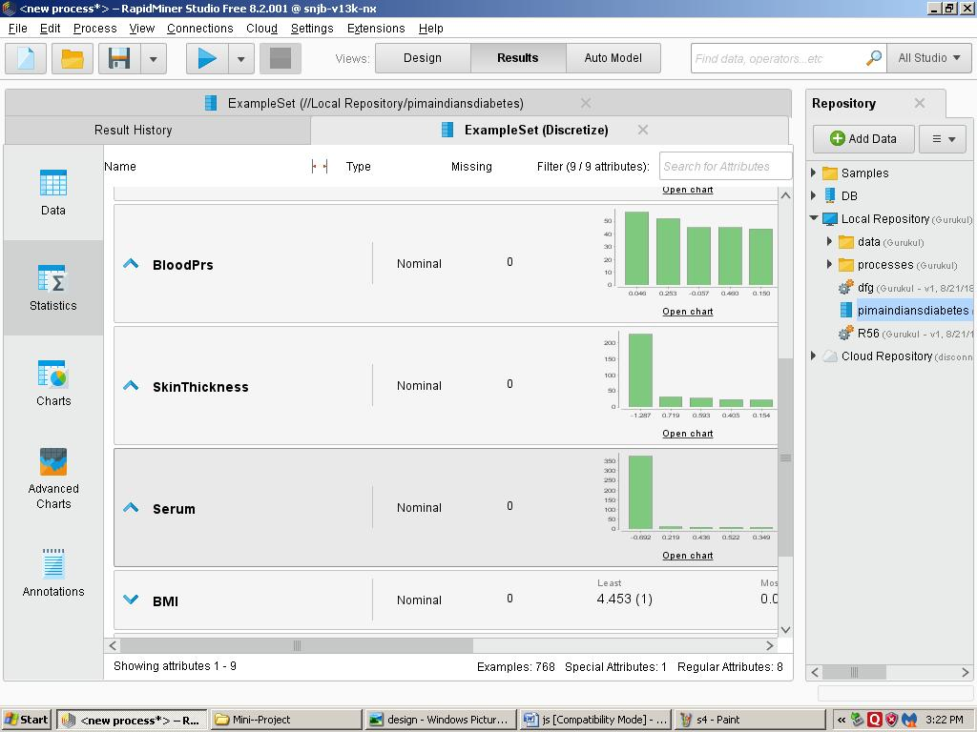
2)

- If you want to view dataset in chart style then press chart.

i)Bars.

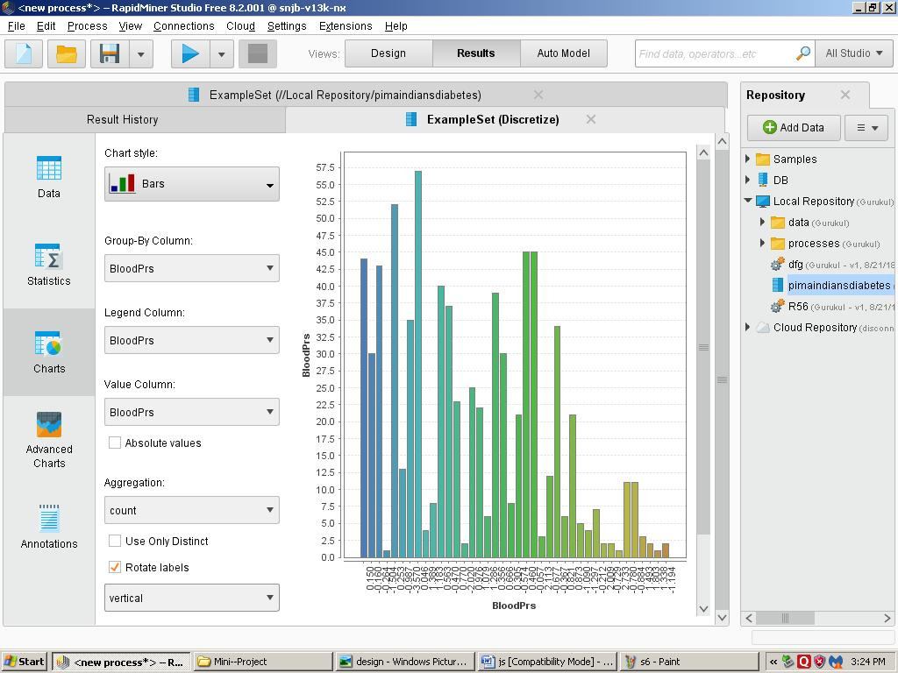

ii)Pie 3D

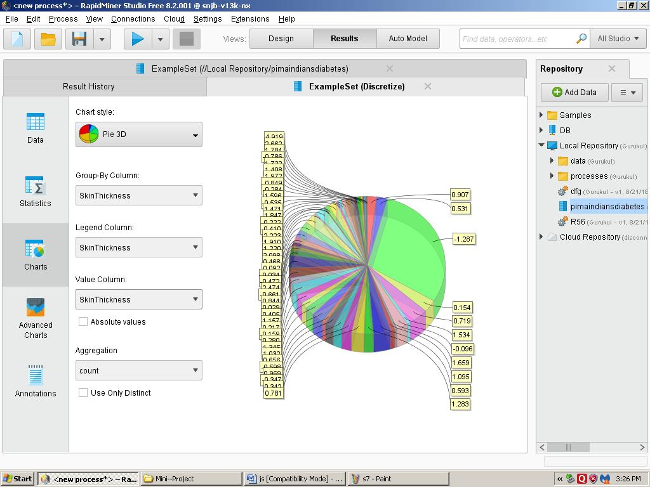

iii)Density

